PART 1: NETWOTK TOPOLOGIES DESIGN AND SIMULATION USING CISCO PACKET TRACER
TASK 1: 5 TOPOLOGIES- MESH, BUS, STAR, RING AND EXTENDED STAR.
1. Bus Topology
It is a network setup where all devices are connected to a single, central cable called the backbone or bus
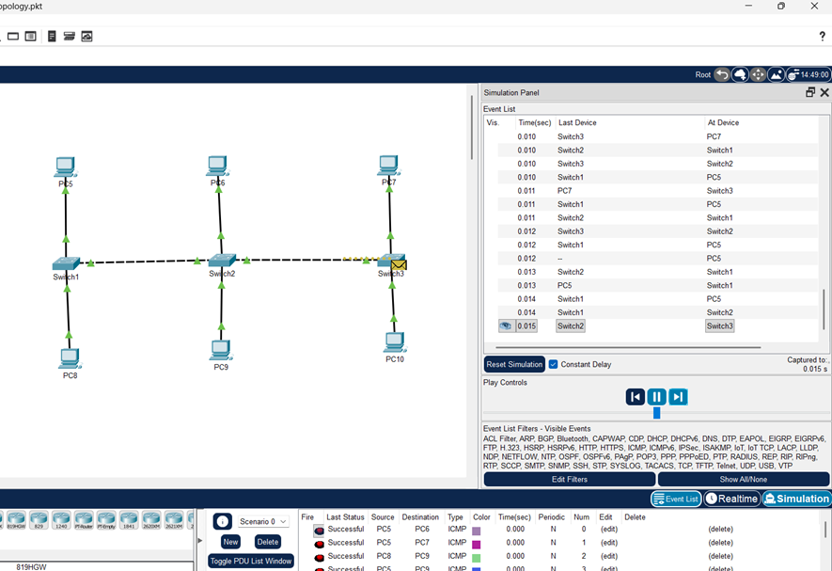
IP Table
Device name | IPv4 Address | Subnet mask
PC5 | 192.168.1.12 | 255.255.255.0
PC6 | 192.168.1.13 | 255.255.255.0
PC7 | 192.168.1.11 | 255.255.255.0
PC8 | 192.168.1.10 | 255.255.255.0
PC9 | 192.168.1.14 | 255.255.255.0
PC10 | 192.168.1.15 | 255.255.255.0
Configuration notes
A classic bus topology was built in Cisco Packet Tracer using a copper cross-over wire that connects 3 switches of the 6 buses as a shared backbone medium. Six computers were connected to this backbone, and each was manually assigned a static IPv4 address from the 192.168.1.10 to 192.168.1.15 range with a uniform subnet mask of 255.255.255.0. As no router was present in this design, the default gateway parameter was intentionally left unconfigured on all end devices. Following the initial setup, connectivity was verified by confirming IP settings via the ipconfig command and executing a full mesh of ping tests. The outcome is a fully functional, isolated local area network where all workstations successfully communicate, validating the correct implementation of the bus topology.
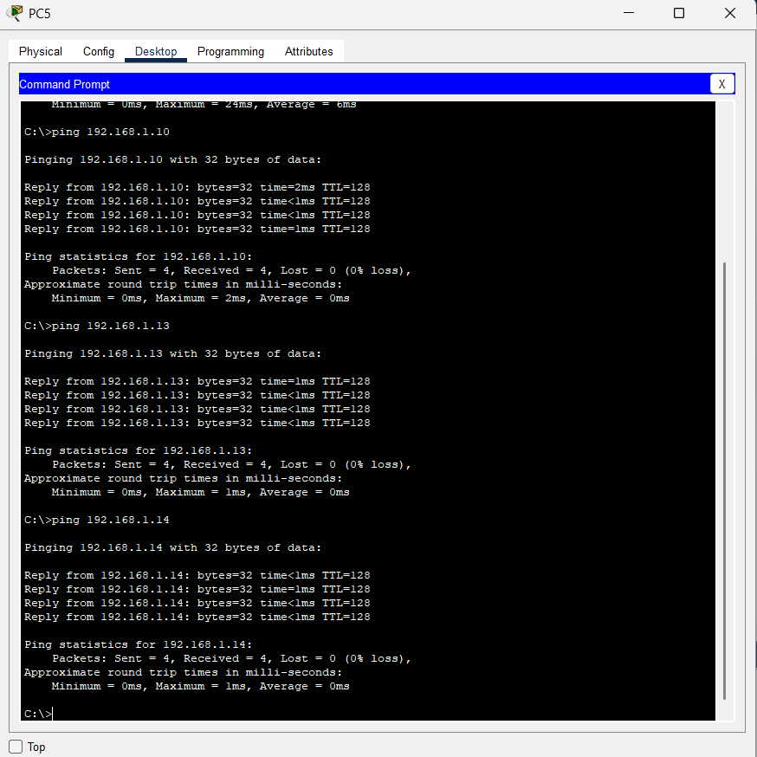

2.Mesh Topology
This is a network design where every device has a direct, dedicated connection to every other device on the network.
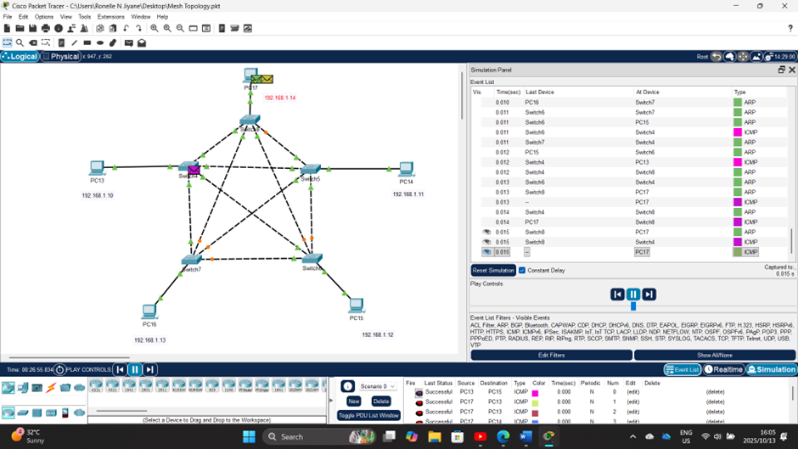
IP Table
Device name | IPv4 address | Subnet mask
PC13 | 192.168.1.10 | 255.255.255.0
PC14 | 192.168.1.11 | 255.255.255.0
PC15 | 192.168.1.12 | 255.255.255.0
PC16 | 192.168.1.13 | 255.255.255.0
PC17 | 192.168.1.14 | 255.255.255.0

Configuration notes
This full mesh topology, comprising five PCs and five switches, is constructed by establishing direct, redundant pathways between all switching devices. Each of the five switches is interconnected with every other switch using crossover cables, forming the robust backbone that defines this architecture, while each PC is connected to its dedicated switch using a straight-through cable. The IP addressing scheme is configured for seamless layer-three communication, with PC13 assigned to 192.168.1.10, PC14 to 192.168.1.11, PC15 to 192.168.1.12, PC16 to 192.168.1.13, and PC17 to 192.168.1.14, all sharing a 255.255.255.0 subnet mask and requiring no default gateway. Following physical setup and IP assignment, verification is performed by executing the ipconfig command on each PC to confirm settings, followed by a comprehensive ping test from every device to all other devices to validate the successful, redundant connectivity inherent to the mesh design.
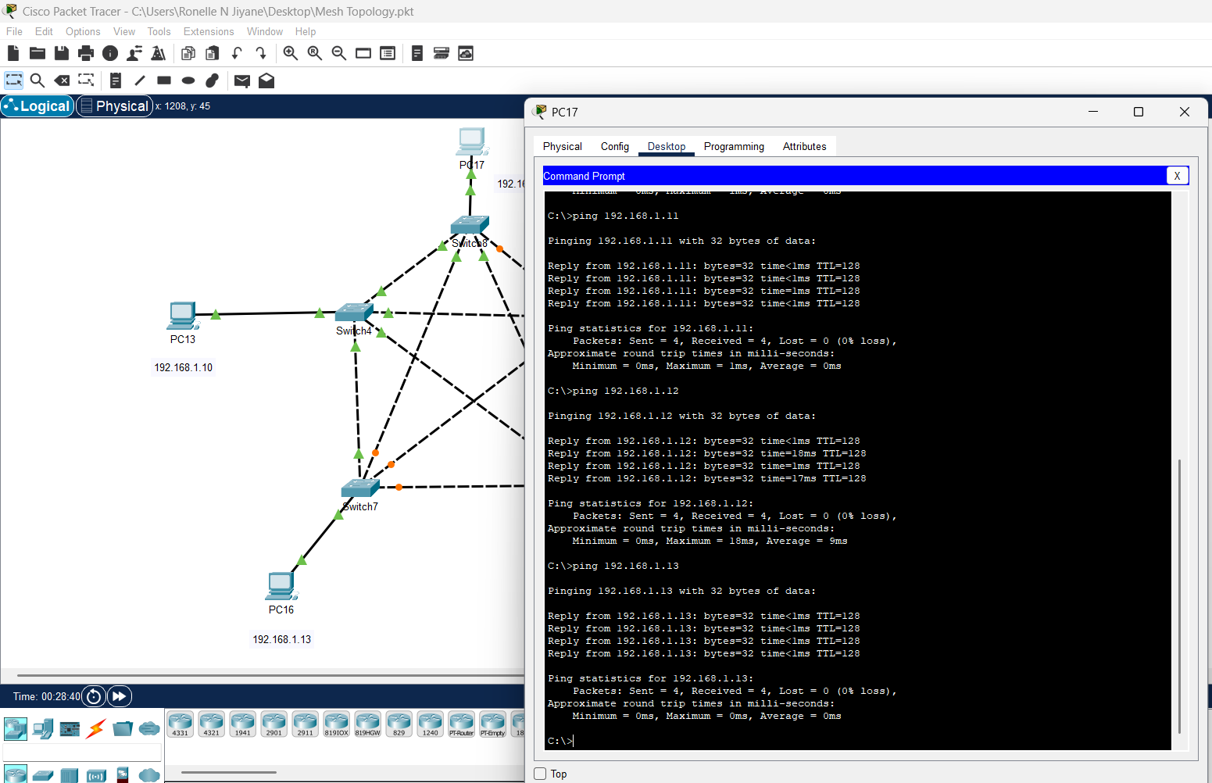

3.Star Topology
A star topology is a network architecture where every device (like computers, printers, or servers) is connected to a central networking device, such as a switch or a hub.
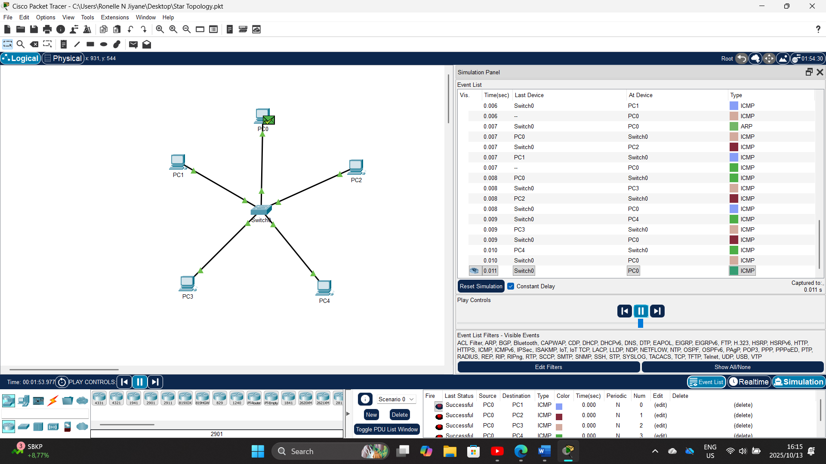

IP Table
Device name | IPv4 address | Subnet Mask
PC0 | 192.168.10.1 | 255.255.255.0
PC1 | 192.168.10.2 | 255.255.255.0
PC2 | 192.168.10.3 | 255.255.255.0
PC3 | 192.168.10.4 | 255.255.255.0
PC4 | 192.168.10.5 | 255.255.255.0
Configuration notes
The star topology is configured with a single switch acting as the central hub, to which all five PCs are directly connected using straight-through Ethernet cables. Each computer is assigned a static IP address on the same subnet: PC0 as 192.168.10.1, PC1 as 192.168.10.2, PC2 as 192.168.10.3, PC3 as 192.168.10.4, and PC4 as 192.168.10.5, all with a subnet mask of 255.255.255.0 and no default gateway required for this isolated segment. Following the physical connections and IP assignments, network functionality is verified by using the ipconfig command on each PC to confirm its settings, and then performing ping tests between all devices to ensure the switch is correctly forwarding traffic, thereby validating the successful implementation of the star network where the central switch manages all data communications.

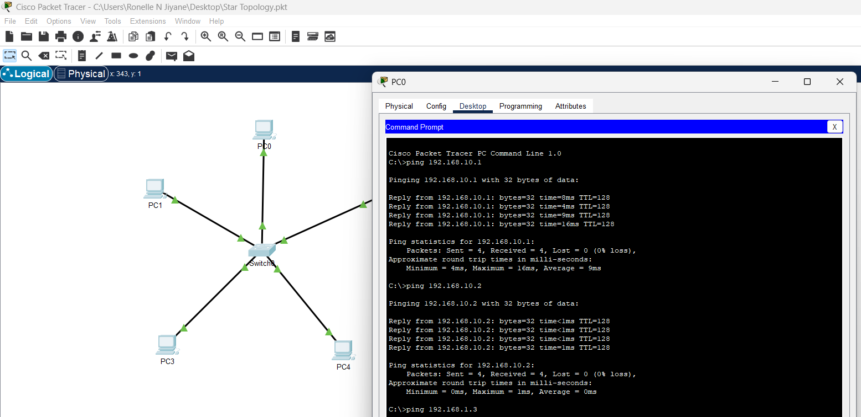

4. Ring Topology
A ring topology is a network configuration where each device is connected to exactly two other devices, forming a continuous circular pathway for data.
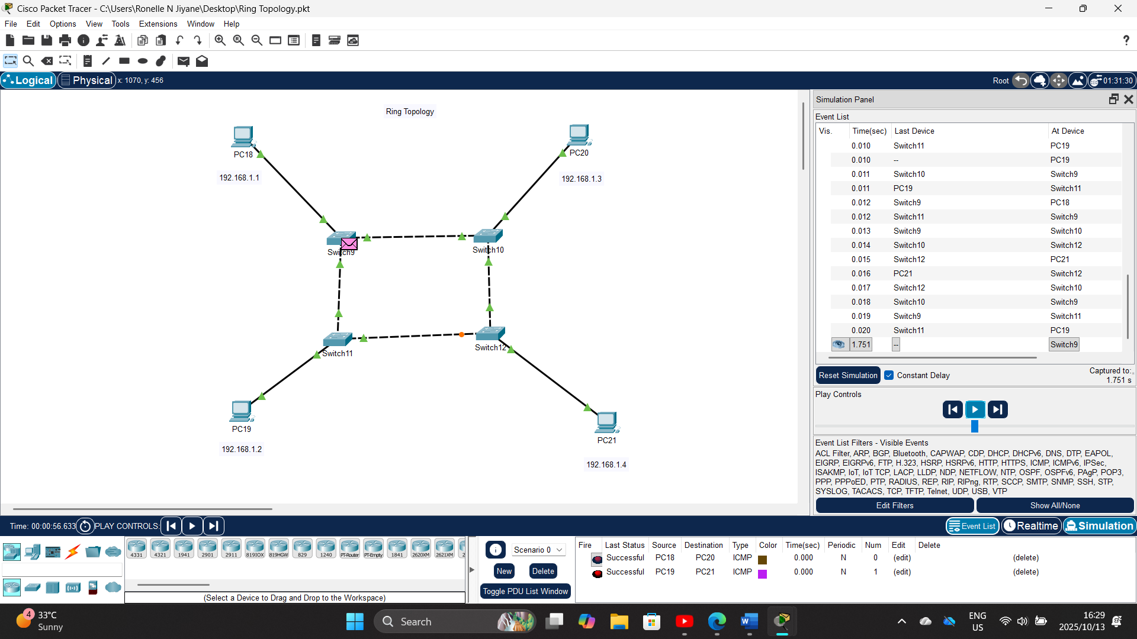
IP Table
Device name | IPv4 Address | Subnet mask
PC18 | 192.155.10.11 | 255.255.255.0
PC19 | 192.155.10.12 | 255.255.255.0
PC20 | 192.155.10.13 | 255.255.255.0
PC21 | 192.155.10.14 | 255.255.255.0
Configuration notes
This ring topology is established by connecting four switches in a closed loop, where Switch 9 connects to Switch 10, Switch 10 to Switch 11, Switch 11 to Switch 12, and Switch 12 back to Switch 9, creating a continuous circular data path using appropriate trunk links. Each of the four PCs is then connected to its own dedicated switch, with PC18 assigned to Switch 9, PC19 to Switch 10, PC20 to Switch 11, and PC21 to Switch 12, and each computer is configured manually with a static IP address on the 192.155.10.0/24 network specifically PC18 as 192.155.10.11, PC19 as 192.155.10.12, PC20 as 192.155.10.13, and PC21 as 192.155.10.14, all with a 255.255.255.0 subnet mask. Following the physical and logical configuration, connectivity is verified by using the ipconfig command to confirm IP settings on each host and then performing a series of ping tests across the ring to ensure data can successfully traverse the circular path, thereby validating the implementation of the token-passing or switched ring architecture where data travels in a unidirectional or bidirectional loop between all nodes.
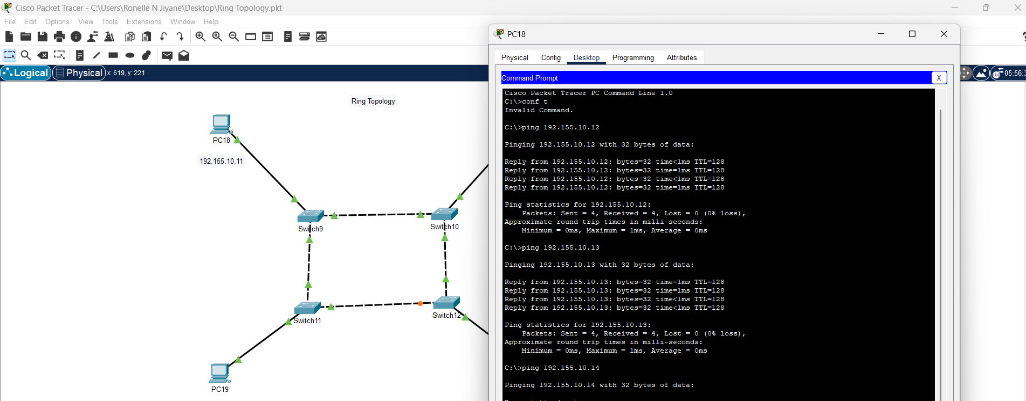
5. Extended Star Topology
An extended star topology is a hierarchical network design where multiple individual star networks are interconnected by linking their central switches.
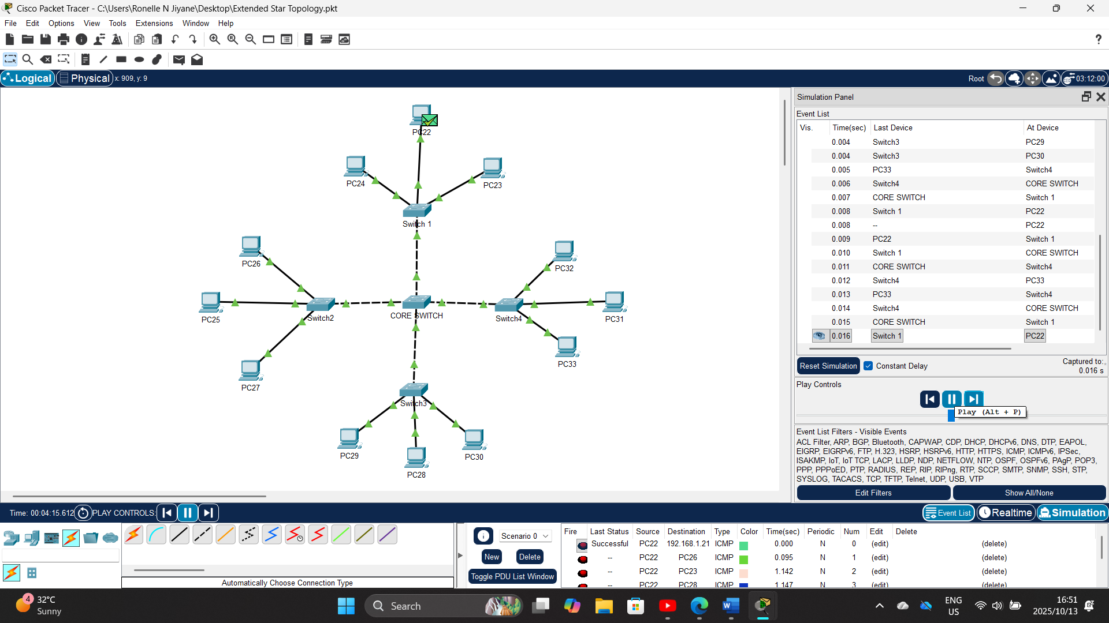
IP Table
Device name | IPv4 Address | Subnet mask
PC22 | 192.168.1.10 | 255.255.255.0
PC23 | 192.168.1.11
PC24 | 192.168.1.12 | 255.255.255.0
PC25 | 192.168.1.13 | 255.255.255.0
PC26 | 192.168.1.14 | 255.255.255.0
PC27 | 192.168.1.15 | 255.255.255.0
PC28 | 192.168.1.16 | 255.255.255.0
PC29 | 192.168.1.17 | 255.255.255.0
PC30 | 192.168.1.18 | 255.255.255.0
PC31 | 192.168.1.19 | 255.255.255.0
PC32 | 192.168.1.20 | 255.255.255.0
PC33 | 192.168.1.21 | 255.255.255.0
Configuration notes
The extended star topology is constructed with a hierarchical design where four access switches, each forming an individual star network for a group of three PCs, are connected via uplink cables to a central core switch that manages all inter-switch communication. The twelve PCs are distributed evenly across the access switches, with three PCs connected to each switch, and are assigned static IP addresses sequentially from the 192.168.1.0/24 subnet: PC22 to PC24 are assigned 192.168.1.10 to 192.168.1.12 on the first switch, PC25 to PC27 are assigned 192.168.1.13 to 192.168.1.15 on the second switch, PC28 to PC30 are assigned 192.168.1.16 to 192.168.1.18 on the third switch, PC31 to PC33 are assigned 192.168.1.19 to 192.168.1.21 on the fourth switch, all using a consistent 255.255.255.0 subnet mask. Following the physical connections and logical IP configuration, network functionality is verified by using the ipconfig command on each PC to confirm its settings and then performing comprehensive ping tests between devices within the same switch, between devices on different switches, and from all endpoints to the core switch to validate the successful implementation of the hierarchical extended star architecture where the core switch efficiently routes traffic between all individual network segments.
